**DA ASSIGNMENT 2**

1. **DONUT CHART**

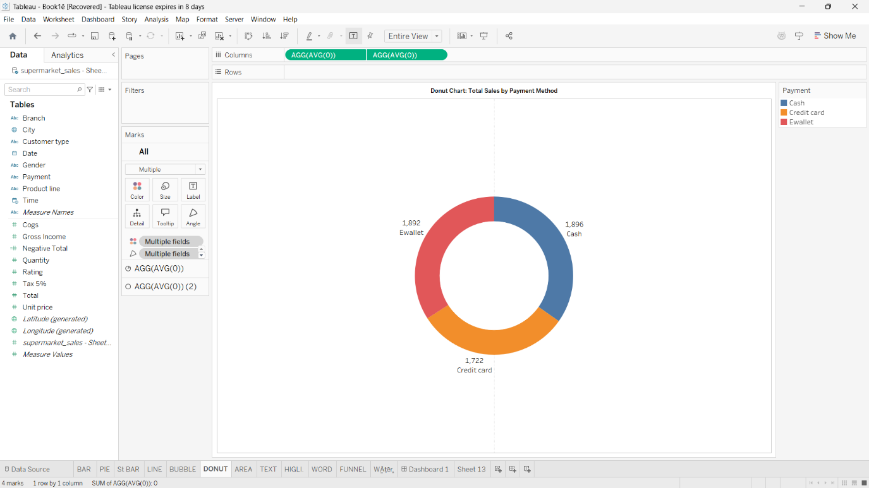

1. **AREA CHART**

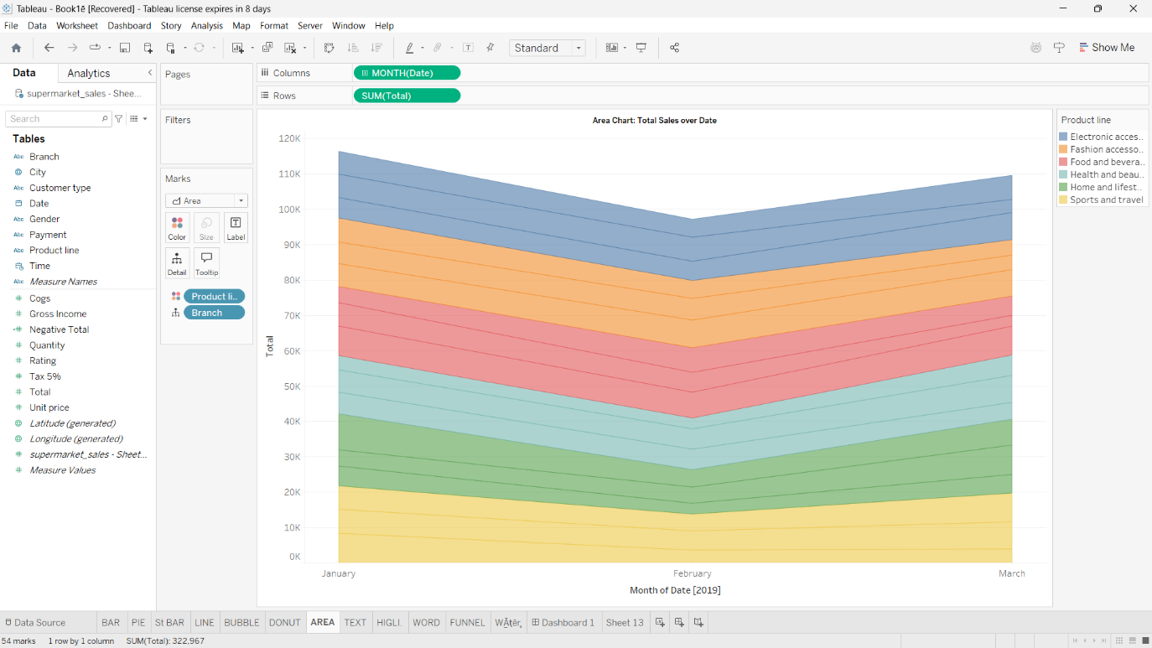

1. **TEXT TABLE**

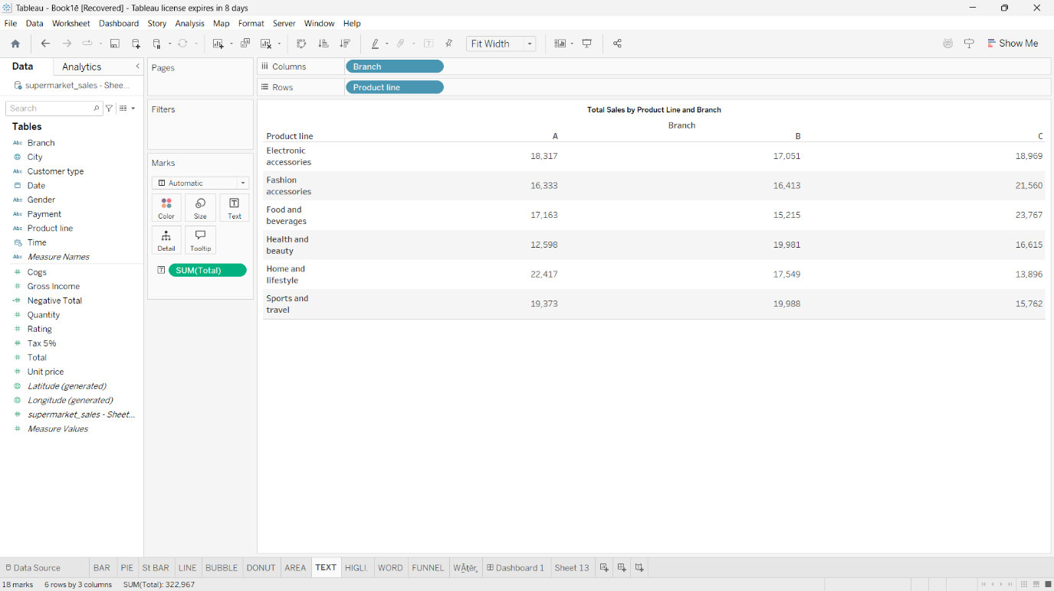

1. **HIGHLIGHTED TABLE**

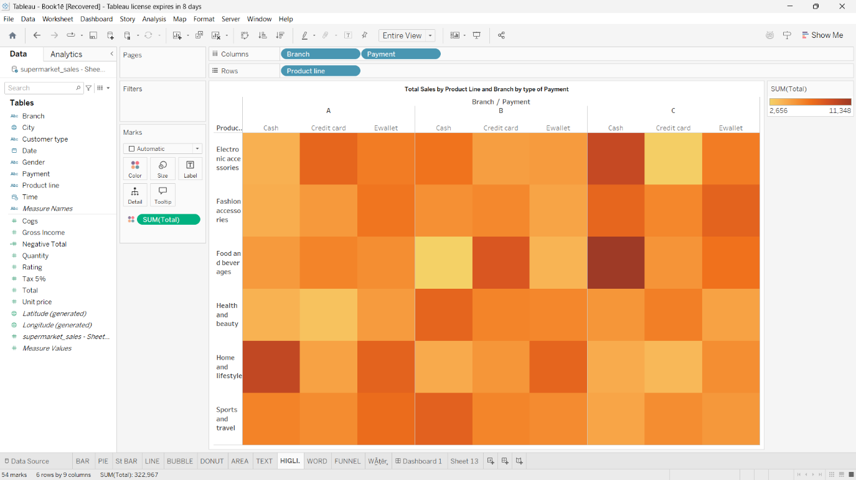

1. **WORD CLOUD**

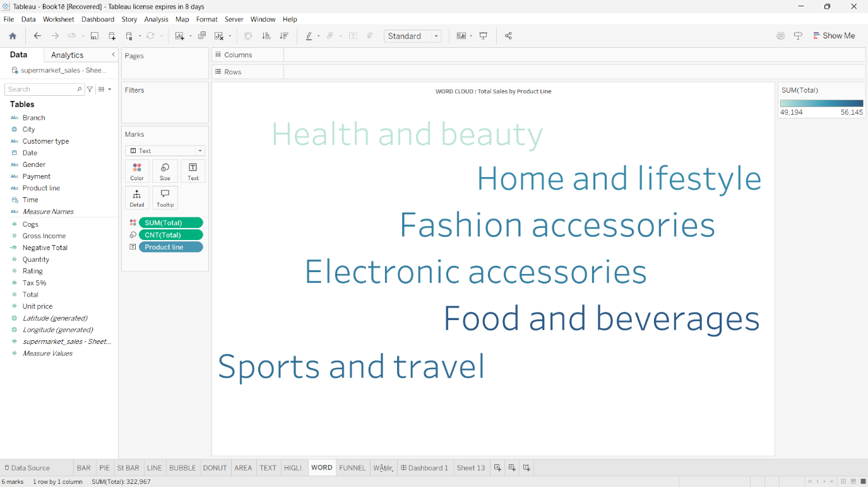

1. **FUNNEL CHART**

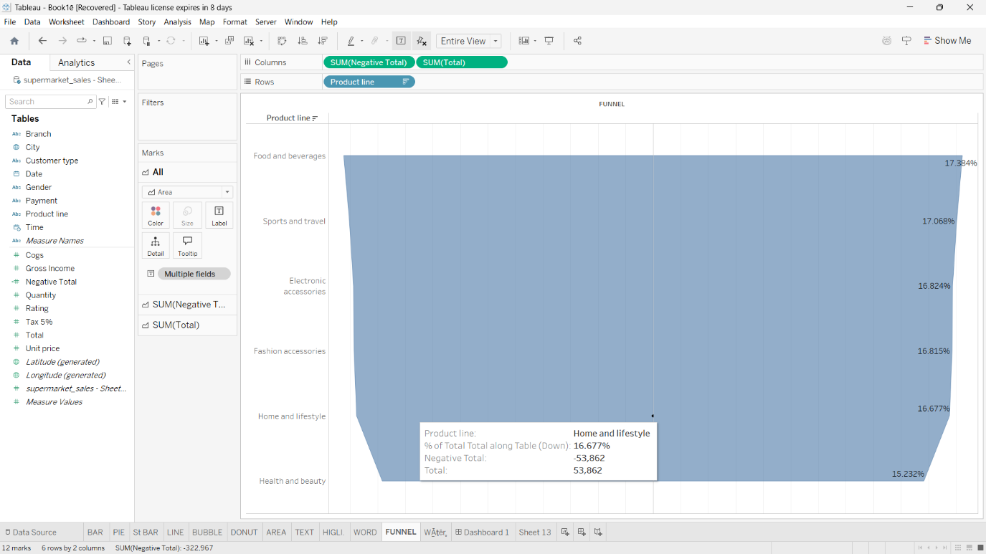

1. **WATERFALL CHART**

